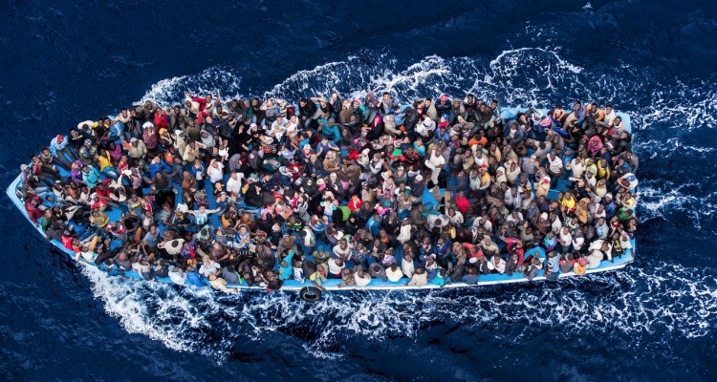
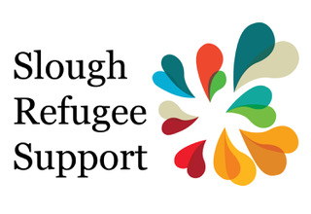
www.sloughrefugeesupport.org.uk
Find us on Facebook
Tel: 01753 537142

Test your knowledge about refugees

Refugees are people who has been forced to leave their homes and countries suddenly, and risk a chance of death if they do not do so. According to international law, it is legal to leave your country to try and find safety in another country and to travel as far as you need to until you find a home.

- What is the main reason refugees flee their countries?
- Poverty
- Unemployment
- War

- How many refugees are there in the world at the moment?
- Approximately 20 million
- Approximately 65 million
- Approximately 3 million

- What percentage of this number of refugees has the UK taken in?
- 1%
- 10%
- 35%

- Is it mostly countries outside or inside Europe who have taken in 4 out of 5 of the world’s refugees?
- Inside Europe
- Outside Europe

- How many of the world’s refugees are estimated to be children?
- 13M
- 5M
- 27M

- Three countries outside Europe each take care of millions of refugees – more than all those taken in by the 50 countries of Europe. Can you name these countries?

We often read about refugees coming to the UK. But what percentage of the UK’s total population are refugees?

12%

5.25%

0.25%

People from many countries are seeking refuge but which country is the source of the most refugees at the moment?

Yemen

Somalia

Syria

For discussion If you had to flee your home and your country, which three things would you want to take with you?

For discussion If you arrived in another country as a refugee, how would you hope to be treated by the people in that country?

